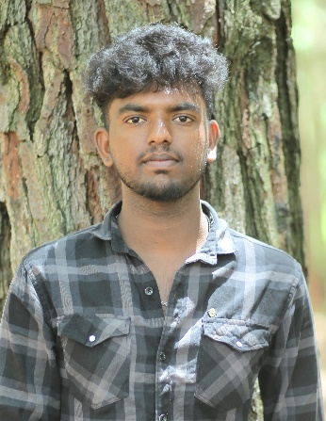

**Professional Skills**

**Front-End:**

HTML, CSS, ReactJS

**Backend:**

Nodejs, JavaScript

**Database:**

MongoDB

# Career Objective

Seeking a challenging IT role that allows me to utilize my technical expertise and problem-solving skills to drive business success and growth.

**Education**

**Master of Computer Application (MCA)**

RVS College of Arts and Science -Coimbatore

* From 2022 to 2024
* Pursuing
* 71% (upto 2nd sem)

**Bachelor of Computer**

**Application (BCA)**

Madurai Kamaraj University College – Madurai

* From 2019 to 2022
* 72%

**HSC**

John Paul Hr Sec School - Dindigul

* From 2018 to 2019
* 60%

# SSLC

Manimekalai Elango Hr Sec School -Devathur

* From 2016 to 2017
* 84%

**Phone:**

+91 6382318872

**Email:**

[sivaharish0202@gmail.com](mailto:sivaharish0202@gmail.com)

**LinkedIn:**

<https://rb.gy/43geg>

**GitHub:**

<http://surl.li/gbuor>

**Address:**

1 3 97

Uppukanda paarai,

North Pachalur,

Kodaikanal,

Dindigul ,

Tamil Nadu -624212

**Contact**

**Projects:**

**Portfolio**

It is Web page which is developed by using HTML, CSS, and JS. Where I have showcased my education, skills, projects and some information’s about me. Which help someone to know about me.

## **Bad Bank Application**

This project is a banking-based web application that allows user to manage account, make transaction and view balance in their account. It is developed by ReactJS.

# E-commerce (MERN)

To secure a challenging role in an e-commerce project utilizing MERN (MongoDB, Express.js, React.js, Node.js) stack, where I can apply my technical skills and creativity to build innovative solutions and drive business growth.

**Languages**

**English:**

R W S

**Tamil:**

R W S

**Declaration:**

I hereby declare that the information furnished above is true to the best of my knowledge.

**SIVAHARISH S**

**SIVAHARISH S**